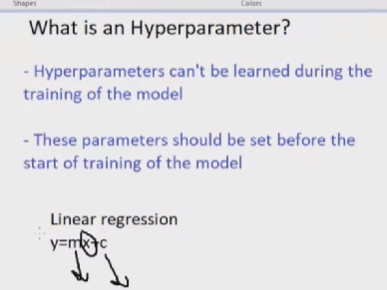
In linear regression x is the input y is the output that we are going to predict, m and c are the parameters with that help of that y will be predicted, so the optimal value to predict y can’t be find in learning stage of the model. So we have to the this hyper parameter to predict y, that is called hyper parameter tuning.
Summary:
Hyper parameter tuning is the process of changing the parameters of the model (weight) to predict the values in desired way. And it can be changed externally.
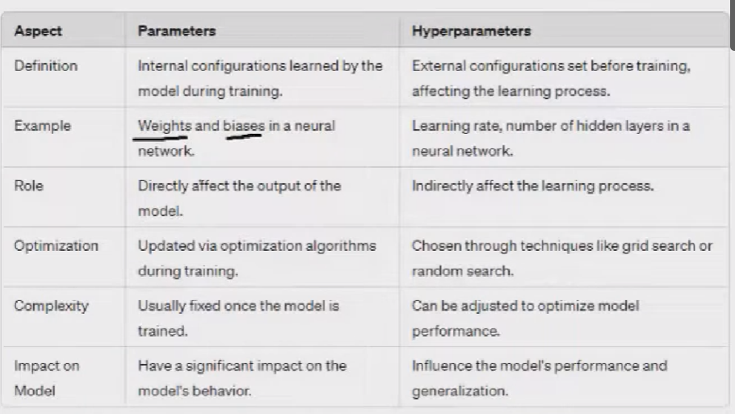
HYPER PARAMETERS IN ALL MODLES:
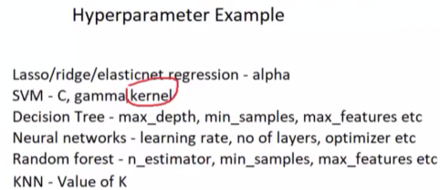
METHODS TO GET OPTIMAL VALUES FOR HYPER PARAMETRES
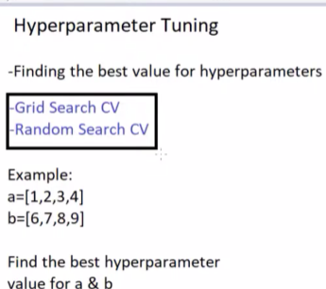

GRID SEARCH CV
In above Cv is cross validations, in grid search it will take all possible combination values
EX:
From the above a and b grid will take 1 and add it with all the values in b, so (1,6) (1,7) (1,8) and so on. This way to takes all combination and looks for accuracy change in model, if a value gives more accuracy the grid search takes that combination.
RANDOM SEARCH CV
It takes random combination from both a and b, and takes the best accuracy score combination, it doesn’t checks all combinations.
METHOD FOR GET HYPER PARAMETERS OF A MODEL
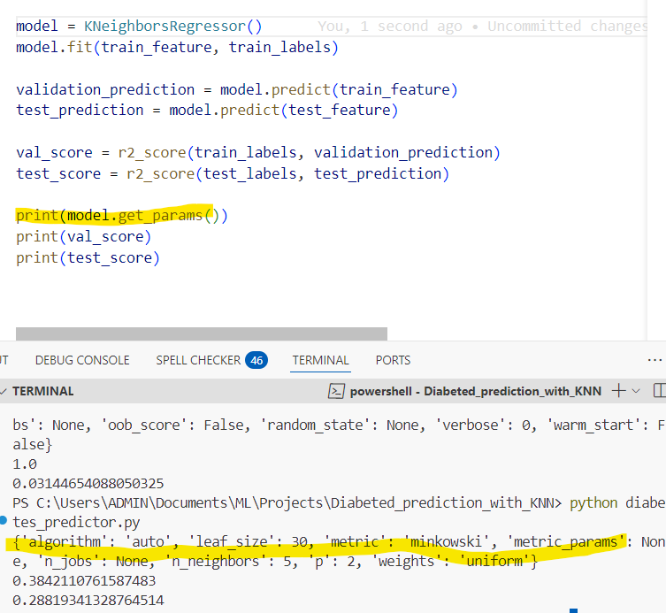
CODE EXAMPLE FOR GRID SEARCH CV AND RANDOM SEARCH
In below code we specify K nearest neighbour model hypers parameters with values in param_grid.
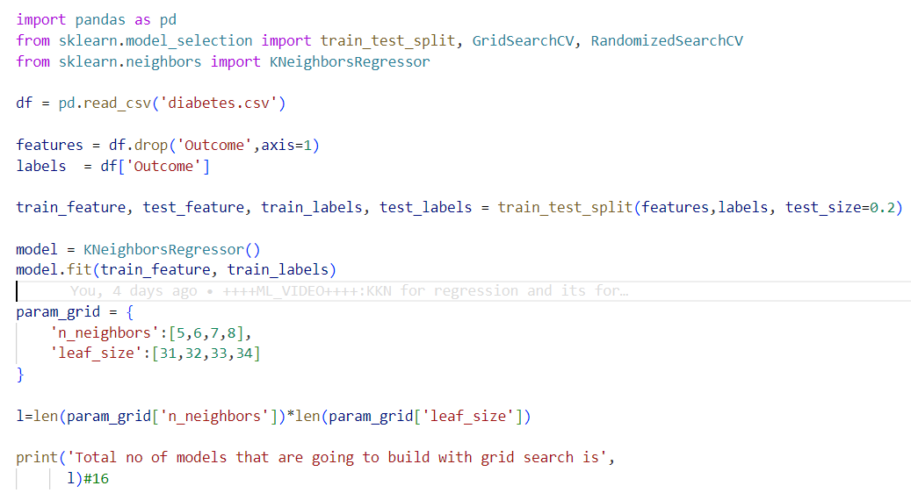
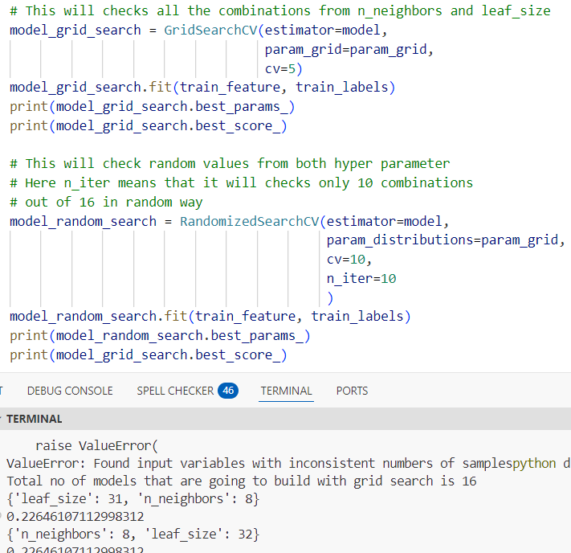
DIFFERENCE BETWEEN GRID AND RANDOM
Finds the best hyper parameter in faster way in random search while grid takes time.

